**COMMANDS TO CREATE VM and INSTALLED KIND IN GCLOUD**

gcloud compute instances create my-instance \

--machine-type n1-highmem-4 \

--image-project ubuntu-os-cloud \

--image-family ubuntu-2004-lts \

--boot-disk-size 20GB \

--zone us-central1-a

gcloud compute ssh my-instance --zone us-central1-a

sudo apt update

sudo apt install docker.io

sudo docker run --memory=10g --name my-container -d ubuntu:20.04 sleep infinity

curl -Lo ./kind <https://kind.sigs.k8s.io/dl/v0.23.0/kind-linux-amd64>

chmod +x ./kind

sudo mv ./kind /usr/local/bin/kind

Kind cluster is created in GCLOUD

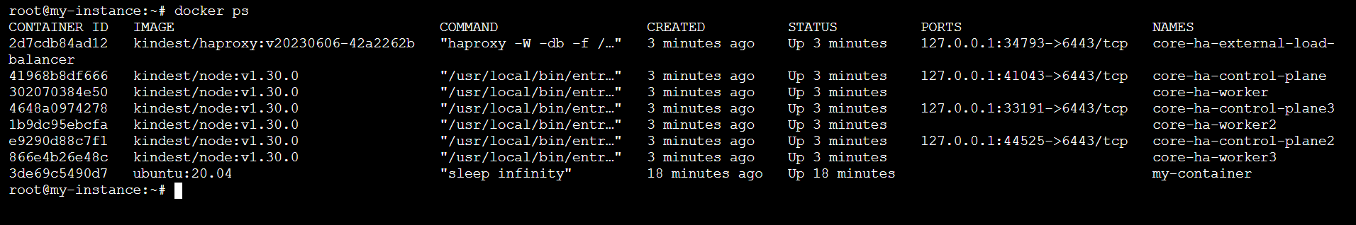

snap install kubectl –classic TO install kubectl in container running Kind

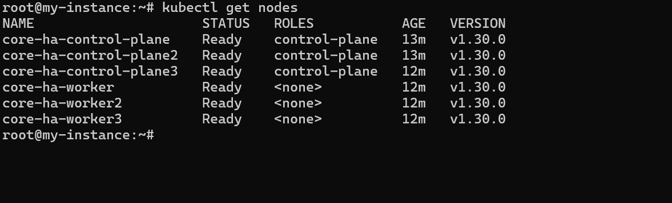

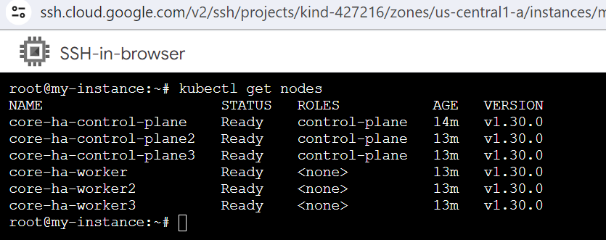

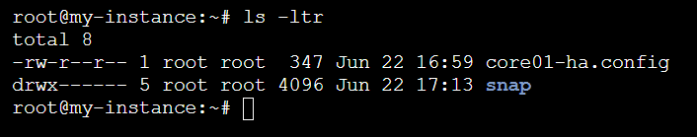

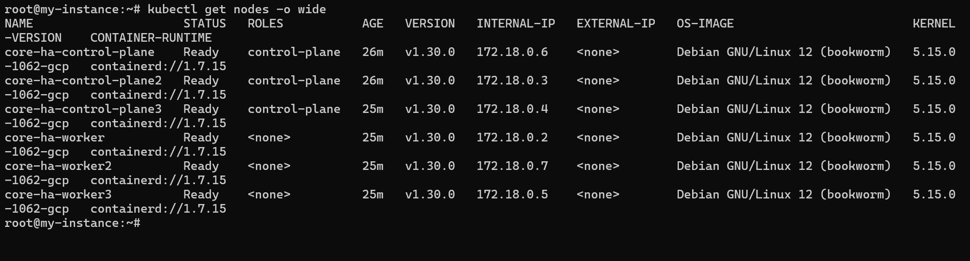

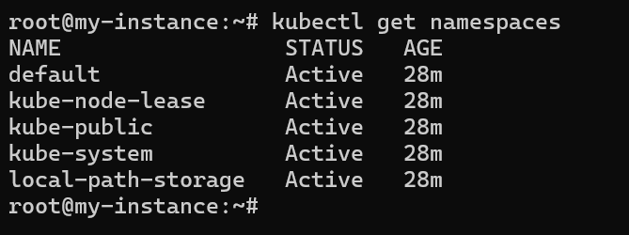

kubectl get pods -n kube-system -l component=etcd

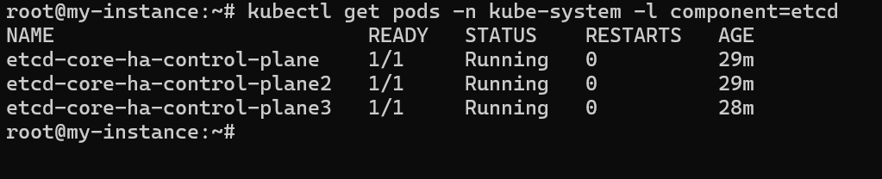

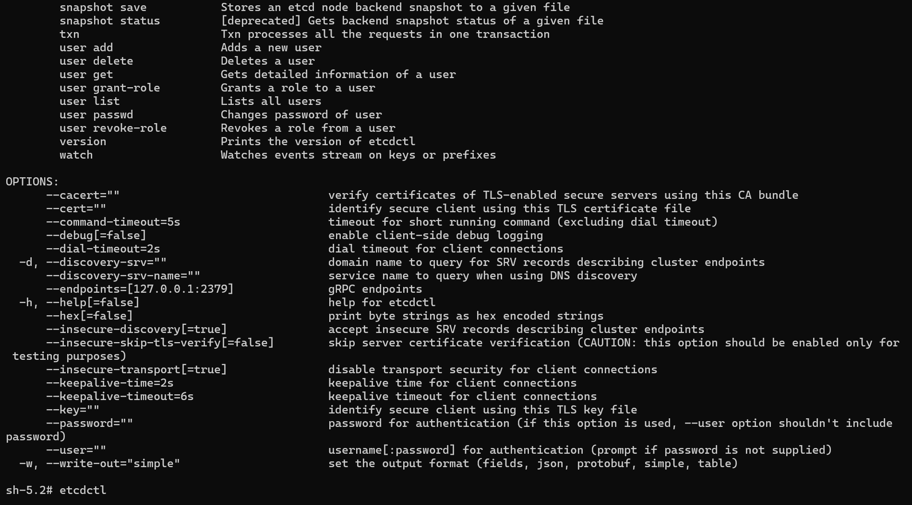

Etcdl version

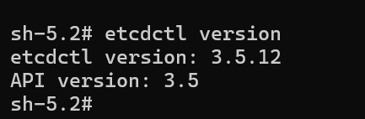

# ETCD client certificate, key, and CA certificate are found in /etc/kubernetes/pki

etcdctl version

export ETCDCTL_API=3

export ETCDCTL_CACERT=/etc/kubernetes/pki/etcd/ca.crt

export ETCDCTL_CERT=/etc/kubernetes/pki/etcd/healthcheck-client.crt

export ETCDCTL_KEY=/etc/kubernetes/pki/etcd/healthcheck-client.key

export ETCDCTL_ENDPOINTS=https://127.0.0.1:2379 # explain where to get this address?

### OR you can use following options with command

ETCDCTL_API=3 etcdctl member list \

--cacert="/etc/kubernetes/pki/etcd/ca.crt" \

--cert="/etc/kubernetes/pki/etcd/healthcheck-client.crt" \

--key="/etc/kubernetes/pki/etcd/healthcheck-client.key" --endpoints=127.0.0.1:2379

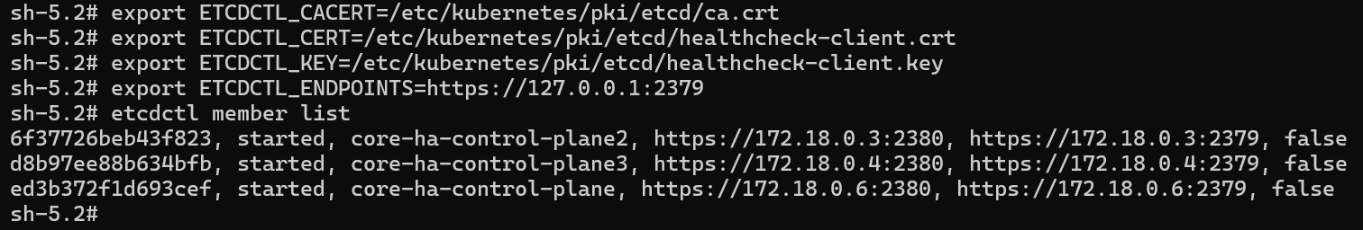

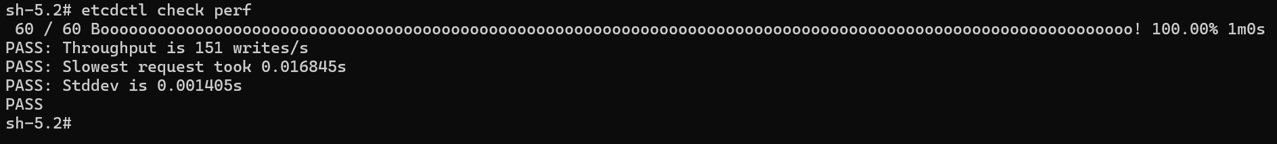

etcdctl endpoint status --cluster –write-out=table

